**Classroom Activity: Verify Node version installation.**

1. **Open Command Prompt.**
2. **Type the following command to verify node installations**

node -v

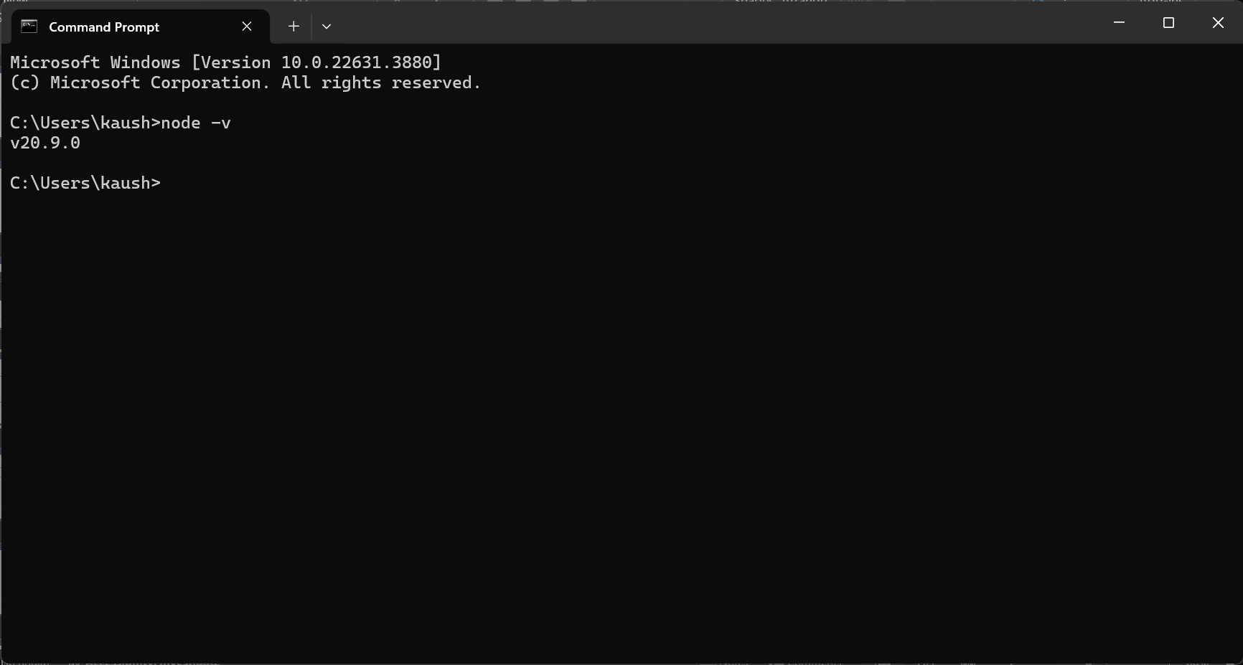

**This will show the installed version of node.**